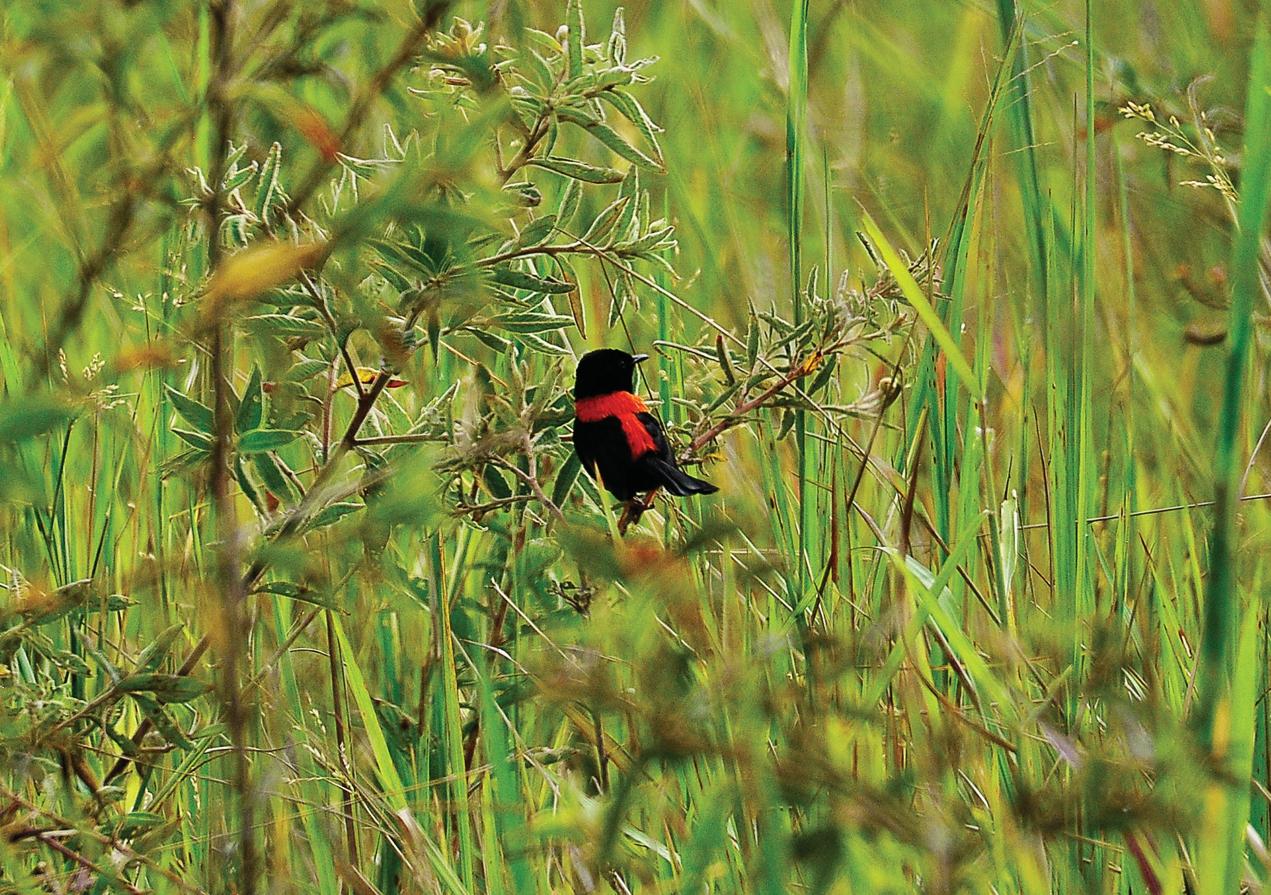
Image Courtesy of HSC (Bird Conference)

Red-backed Fairy-Wren


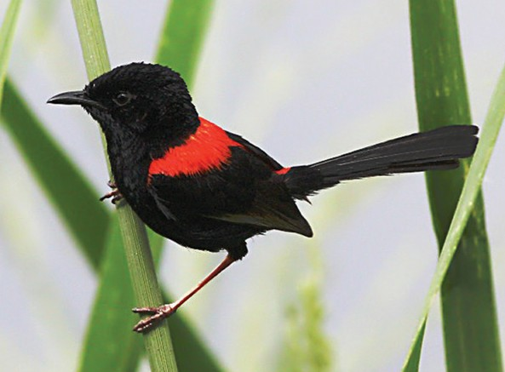
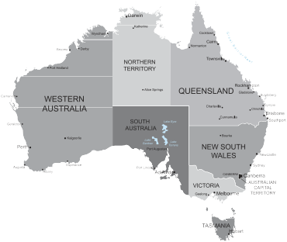
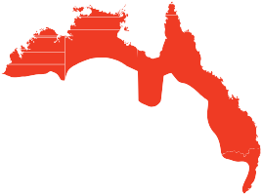

Fast Facts

Scientific Name: Malurus melanocephalus Other Name:

Size:
11cm

Weight:
8g

Gestation/Incubation:
12 days

Number of young/eggs:
3 eggs

Conservation Status

Extinct
Extinct in the Wild Critically Endangered Endangered Vulnerable
Near– Threatened
Secure

Did You Know?

- This is the smallest of the Fairy- wrens and is sometimes known as the Elfin Wren.
- The male can have a “harem” of up to 5 females.
Description
The Red-backed Fairy-wren is the smallest of the fairy-wrens. Breeding males are glossy black with a vivid red saddle on the back and rump. Adult non breeding males and juveniles are similar in colouring to females which are a pale warm brown. Females have a pinkish-brown bill while males will always have a black bill.

Diet
Diet consists of small insects, moths and spiders. They regularly forage in pairs or small family groups.

Distribution
Red-backed Fairy-Wrens are endemic to Northern and Eastern Australia from Kimberley Region of West Australia across the Top End to Cape York down through to Northern New South Wales. They are found in Tropical and Sub Tropical areas in tall grasses.

Threats
This bird is quite secure in population but clearing and fire can have an impact on the extended spread of population.

Life Cycle
Breeding season is normally August to January. 2 to 3 white eggs with brown spots are laid in a small dome shaped, grass and fur lined nest that is well hidden in long grass. Only the female incubates the eggs but both parents along with a band of helpers feed the chicks. This wren is one of the least faithful birds in the world with eggs often fathered by various males.

Location in TYTO Wetlands/Parklands
Most commonly spotted in long grass and shrubs at edges of Wetlands walking tracks all year.

