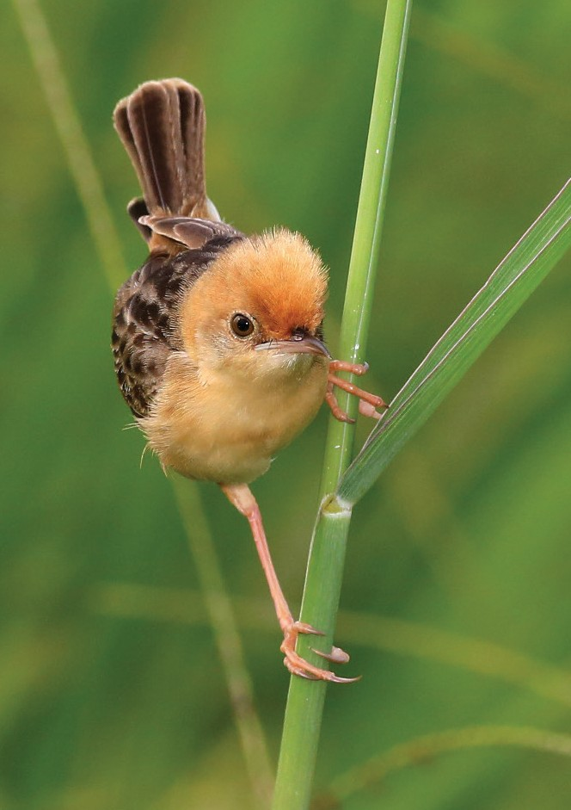
Image Courtesy of tytotony.blogspot.com

Golden-headed Cisticola


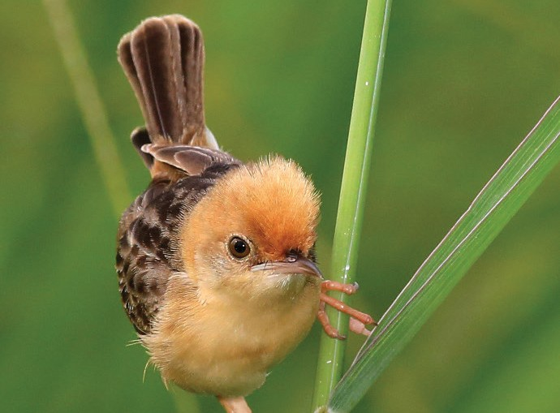
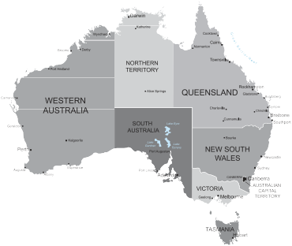
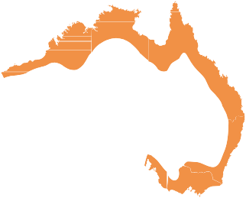

Fast Facts

Scientific Name: Cisticola exilis Other Name:

Size:
10cm

Weight:
10g

Gestation/Incubation:
15 days

Number of young/eggs:
3-4 eggs

Conservation Status

Extinct
Extinct in the Wild Critically Endangered Endangered Vulnerable
Near– Threatened
Secure

Did You Know?

- Otherwise known as Tailorbird or Sewing Machine Bird because its nest is stitched together using grass and cobwebs.
- Has a fluid buzzing call and scolding alarm call. In
breeding season calls almost continuously.
Description
When in breeding season the male Cisticola has a golden-orange head, which is crested when calling, with a boldly streaked black to dark grey, golden body. Females resemble non breeding males and have a buff brown upper part, heavily streaked with black and dark brown. Juveniles are duller than the females.

Diet
Feeds predominantly of insects taken from the ground amongst tall grasses. Also feed on grass seeds.

Distribution
Their range is the sub-coastal area of Northern West Australia, Northern Territory and Eastern States including Tasmania. It is rare in South Australia. They can also be found In India and Southern China. Lives in sub-coastal areas, wetlands, rivers and irrigated farmlands. Prefers vegetation close to the ground but males can be spotted singing from tall weeds or other shrubs.

Threats
While the population is secure in all states except South Australia, this bird may be at risk from habitat loss, uncontrolled fire and predation by feral animals.

Life Cycle
Breeding season is generally September to March. After breeding a rounded nest is built using fine grass, plant down and cobweb. Leaves are usually stitched to the outside. While nests are built by both sexes only the female will incubate the eggs.

Location in TYTO Wetlands/Parklands
Hard to spot in long grass area of Wetlands most months.

