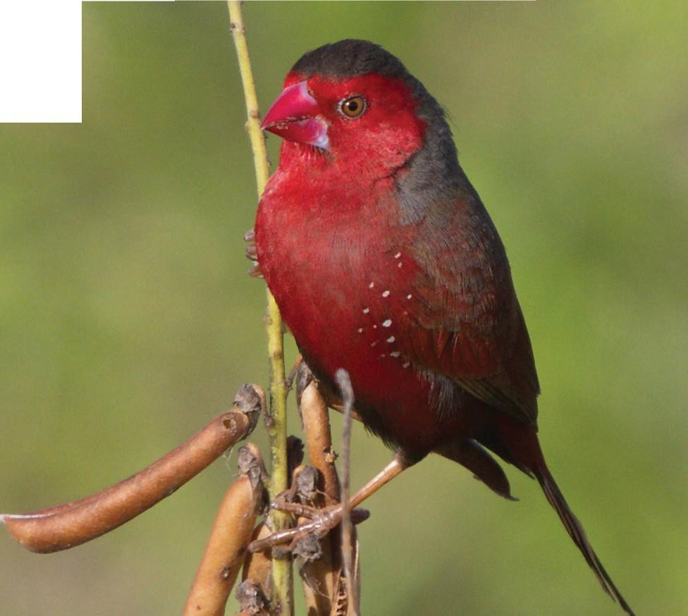


Image Courtesy; of, HSC (Bird Conference)

Crimson Finch


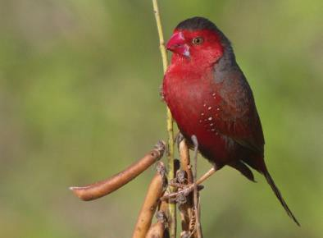
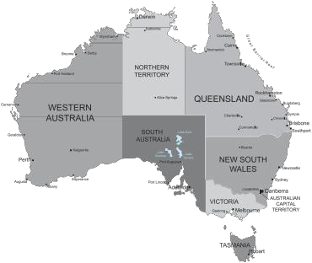


Fast Facts

Scientific Name: Neochmia phaeton Other Name:

Size:
12cm

Weight:
8-10g

Gestation/Incubation:
12 days

Number of young/eggs:
4-8 eggs

Conservation Status

Extinct
Extinct in the Wild Critically Endangered Endangered Vulnerable
Near– Threatened Secure

Did You Know?

- Crimson Finch’s have been known to nest in windows of houses around cane fields.
- Both sexes incubate the eggs and feed the young.
Description
Male Crimson Finches have a brownish crown and nape with a bright crimson face and grey underbody. Most of the underparts of the male are bright crimson. The female crimson finch is a duller red overall with a brownish grey breast and flanks.
Diet
While grass seeds form the major part of the Crimson Finch diet, during breeding, insects are added to the diet.

Distribution
Widespread in Northern Australia, this finch occurs from the Kimberley region of West Australia across the top end of Northern Territory, Gulf Country of Queensland and North East Queensland. Crimson Finches can also be found in southern New Guinea.

The favoured habitat is mixed eucalyptus and pandanus woodlands with a tall understory of grass. They are often found along the edge of cane fields.

Threats
The Crimson Finch population nationally is stable but like all native wildlife they can be at threat by feral animal predation and habitat loss.

Life Cycle
Crimson Finches lay up to 8 white eggs in their bottle shaped nest made of coarse grass and bark. The Pandanus tree is a very popular nesting site. Eggs are incubated by both sexes. Both sexes feed the young while only the female broods the young at night.

Location in TYTO Wetlands/Parklands
Plentiful all year in Wetlands and Parkland Gardens.

